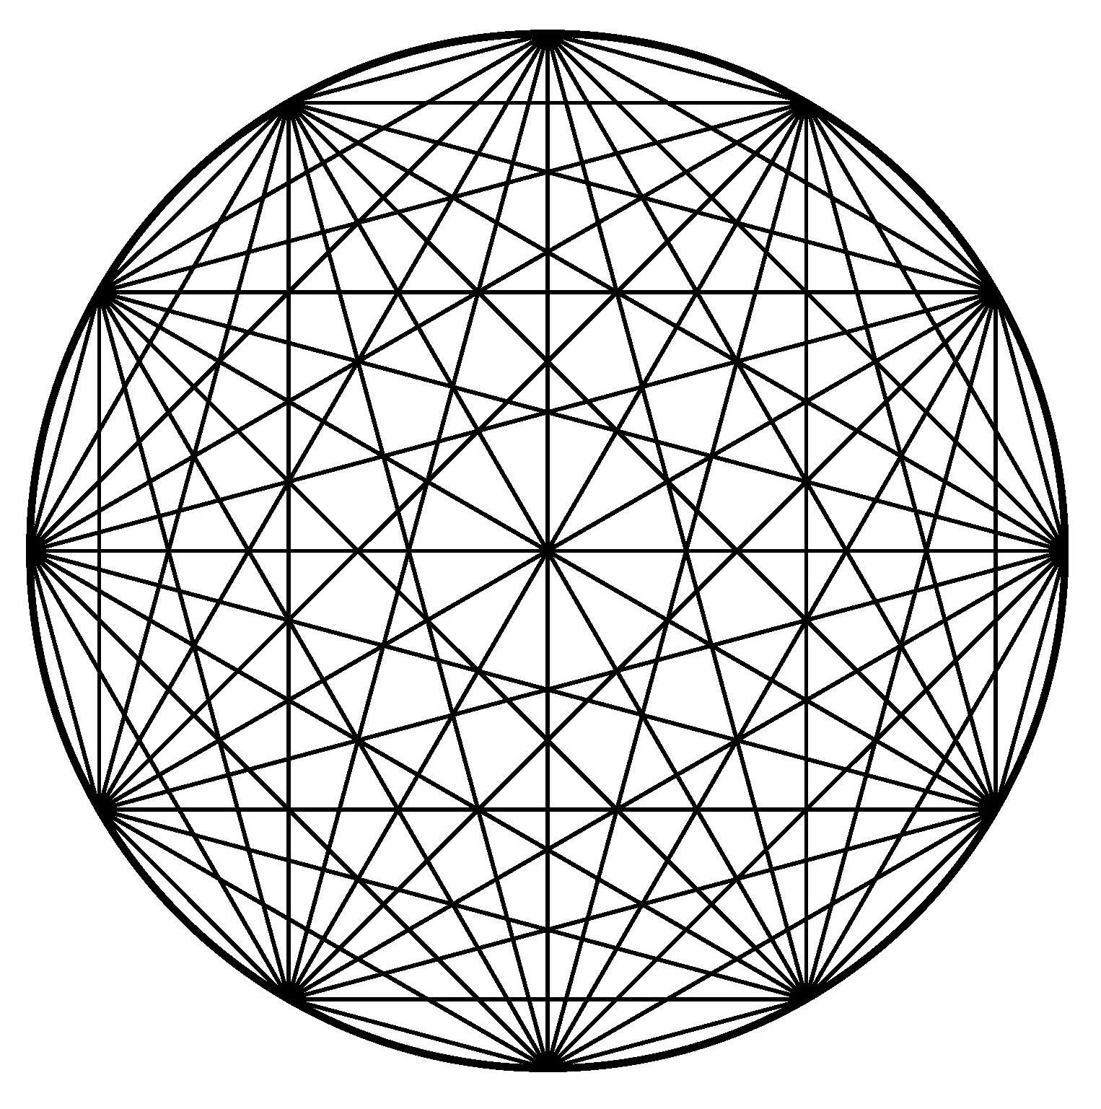 | To: Scuola di Alta Formazione in Conservazione e Restauro  Presso il Palazzo Vercillo-Martino a Rende (CS)  To the Secretariat:  Via Francesco Belmonte, 12 - 87036 Rende (Cosenza)
I, the undersigned *
ON

BORN IN

FIRST NAME AND LAST NAME

DOMICILED IN (CITY, COUNTRY)

PROVINCE (Italy only)

..
STREET NUMBER

ZIP CODE

NATIONALITY

STREET NAME

TAX CODE (if not Italian, please provide any other applicable identification number, e.g., Social Security Number, etc.)

TELEPHONE

E-MAIL

HEREBY APPLY

Wanting to participate in the free RITUALITY, SACRED SPACE and VALORISATION Workshop

He asks to receive the link to the e-mail :_____________________________________________________

He declares to know that the workshop will be in Italian.

He requests the release of the certificate of participation

NO
YES | Free for CORE members for the year 2020 and student
YES | With a contribution of € 30.00 for those who are not members
YES | I ask to register with CORE for the year 2021 and receive the certificate with an all-inclusive contribution of € 50.00

I will make the payment by the start date of the workshop on the IBAN code n ° IT84K0706280880000000125029 - BIC/SWIFT n° BPPIITRRXXX CREDITO COOPERATIVO MEDIOCRATI SOC.COOP. A R.L - branch of Rende. Headed to ASSOCIATION CO.RE

Signature ……………………………………..

I, the undersigned, authorize CO.RE to enter and store all the information contained in the submitted documents within its records, and to use it for the purposes of this Award, without prejudice to my right to obtain at any time the erasure thereof by sending a written request to the address: Via F. Belmonte, 12 87036 Rende (CS) - Italy (Law 675/96)

To be filled in by the Secretariat
Place and Date ……………………………  Signature …………………………………….. | Entry Ref. No. | Certificate

